|  |  |
| --- | --- |
|  | FPT ACADEMY INTERNATIONAL  FPT – APTECH COMPUTER EDUCATION |

Centre Name: ACE-HCMC-2-FPT.

Address: 590 Cach Mang Thang 8, District 3, Ho Chi Minh City, Viet Nam.

**[Cera – World of Tile]**

|  |  |  |
| --- | --- | --- |
| Supervisor: | Phạm Thị Lánh | |
| Term: | 1 | |
| Batch No: | T1.2209.E0 | |
| Group No: | 2 | |
| Order: | Full name | Roll No. |
| 1. | Khoáng Quốc Huy | Student1407969 |
| 2. | Nguyễn Hữu Đức | Student1405216 |
| 3. | Phạm Anh Quốc Dương | Student1405208 |
| 4. | Lê Thành Trung | Student1407973 |

Month 11 Year 2022



This is to certify that

**Mr. KHOÁNG QUỐC HUY**

**Mr. NGUYỄN HỮU ĐỨC**

**Mr. PHẠM ANH QUỐC DƯƠNG**

**Mr. LÊ THÀNH TRUNG**

Have successfully Designed & Developed

**CERA – WORLD OF TILE**

Submitted by:

**Ms. PHAM THI LANH**

Date Of Issue: November, 2022

Authorized Signature:

# Content

Content 3

Acknowledge 4

Synopsis 5

REVIEW 1 6

Problem Definition 7

Customer Requirements Specifications 8

Architecture and Design of the project 9

Site map 10

Website Design Layout 11

I. Homepage 11

II. Main Category Pages 13

III. Comparison Page: 19

Task Sheet 20

REVIEW 2 21

# Acknowledge

As we understand that the eProject is a step-by-step learning environment that closely simulates the classroom and Lab based learning environment into actual implementation. It is a project implementation at your fingertips!! An electronic, live juncture on the machine that allows you to.

✓ Practice step by step i.e., laddered approach.

✓ Build a larger, more robust application.

✓ Usage of certain utilities in applications designed by the user.

✓ Single program to unified code leading to a complete application.

✓ Learn implementation of concepts in a phased manner.

✓ Enhance skills and add value.

✓ Work on real life projects.

✓ Give a real-life scenario and help to create applications more complicated and useful.

✓ Mentoring through email support.

We would like to send a great thank to our professor and others student for the adorable support during the time in the project.

Beside several mistakes we had made in the project, we hope to have more opportunities to widen our knowledge in the web developing world.

We also thank you so much for your information and the “demo” project from India APTECH to help us get more reality experience in this project. Since we have gained more experience from this project, we will not stop learning anything as much as we can to be more successful in the future.

Your Sincerely,

Team Group 02.

# Synopsis

- The Objective of this program we aim is to give a sample project to work on real life projects. These applications help us build a larger, more robust application.

- The objective is not to teach us HTML/JavaScript but to provide us with a real life scenario and help us create basic applications using the tools.

- Hence, we can revise the chapters before we start with the project.

- The Objective of this program is to give a sample project to work on real life projects. These applications help you build a larger, more robust application.

- The objective is not to teach you the software but to provide you with a real-life scenario and help you create basic applications using the tools.

- You can revise the topics before you start with the project.

- This project is meant for students who have completed the module of HTML5.

- These programs should be done in the Lab sessions with assistance of the faculty if required.

- The website (in this project) is a tool that help the company to access the

international market and gain more and more new customers.

- It is very essential that a student has a clear understanding of the subject.

# REVIEW 1

## Problem Definition

Cera’s is an organization selling entire range of ceramic tiles and related products. They provide variety of tiles suitable for each and every kind of construction starting from office to home and etc.

The website is to be developed for the Windows Platform using HTML5, JavaScript and Geolocation. The site should work well in all leading browsers including Chrome, IE, Firefox etc.

Here are some problems need to be resolved:

1. In this flat world of the internet, website is where we can provide details of products to customers. By one click online, Cera would like to help customers to navigate through main categories of products on their home page:
2. Wall tiles
3. Floor tiles
4. Special tiles
5. Under their key categories, customers can view available sub-categories of each main category above. All products will be displayed with pictures, features as well as products’ information.
6. Cera also would like to bring along all details of information of products to customers by allowing them to access Cera online ‘e-catalogue’ built in the website
7. With intention to enhance experiences as well as knowledge base for customers, Cera also provides an ‘Expert Corner section where blogs, tile guide, educational videos can be found and available for customers.
8. The webpage is the place where customers can easily find ‘information of Cera’ with navigation of GoogleMaps under Contact section. This helps to bridge a communication between Cera and Customers.

## Customer Requirements Specifications

|  |
| --- |
| USER: |
| Input:  ● Access website with navigate main categories  ● webpage with multiple pages to allow customers to search for products, or select 2 products for comparison |
| Process:  ● when a category is selected, pictures of products, information will be displayed  ● Comparison will be processed when customers select 2 products |
| Output:  ● Show pictures of products, information  ● Details of comparison are displayed |

|  |
| --- |
| WEBMASTER: |
| Input:  ● Control website database, input product information,… |
| Process:  ● Analyse website |
| Output:  ● Website interface, images, forms, …  ● Giving interaction |

|  |
| --- |
| HARDWARE / SOFTWARE REQUIREMENT: |
| Software:  ● Notepad/HTML editor  ● Dreamweaver/Javascript |
| Hardware:  ● A minimum computer system that will help you access all the tools in the courses is a Pentium 166 or better  ● 64 Megabytes of RAM or better |

## Architecture and Design of the project



## Site map

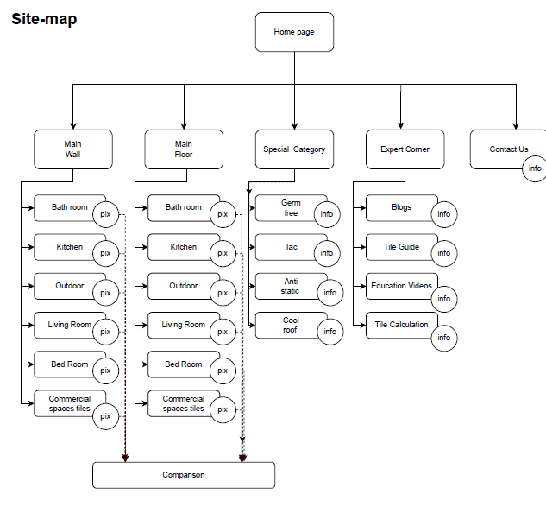

## Website Design Layout

### Homepage

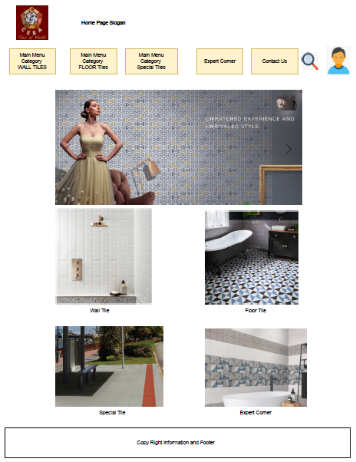

**Description:** This is a homepage of Cera, the top of this page is a header, after that is a navigation bar.

The main navigation bar consists of 5 different categories:

* Main category of Wall Tiles
* Main category of Floor Tiles
* Main category of Special Tiles
* Expert Corner
* Contact Us

The footer of a homepage has some keys of information such as copy right and summary site map

### Main Category Pages

#### **Wall Tile page:**

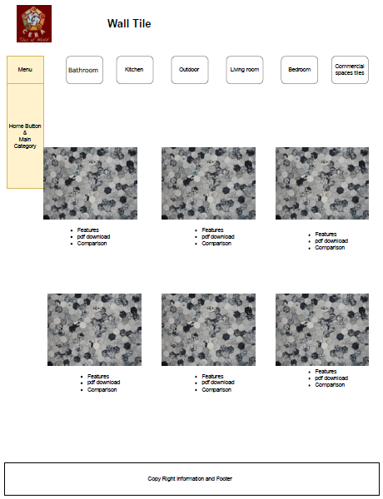

#### **Floor Tile page:**

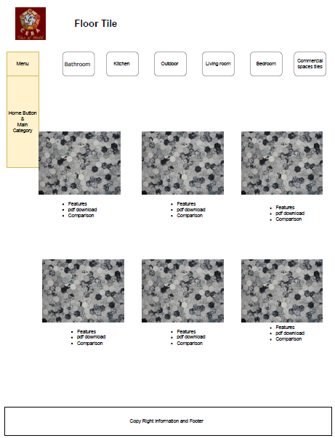

#### **Special Features Tile page:**

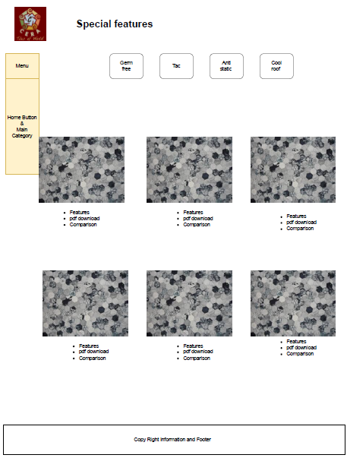

#### **Expert Corner Page:**

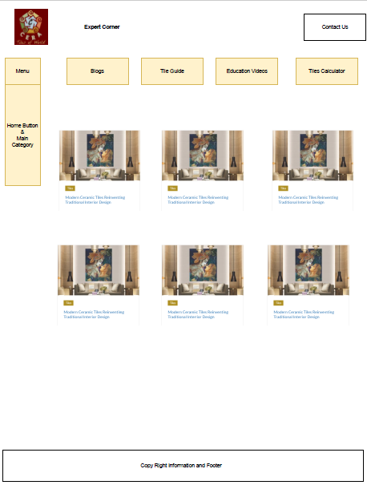

#### **Contacts page:**

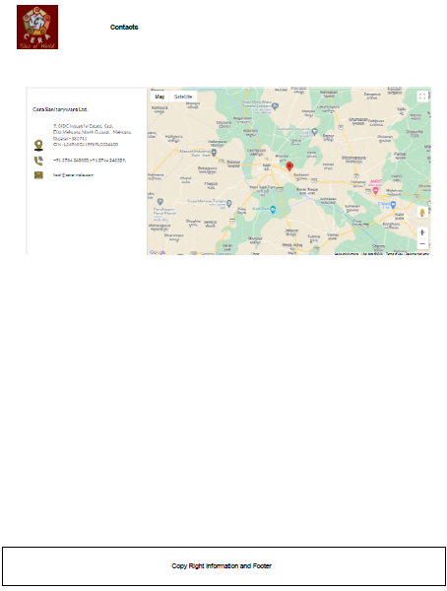

**Description:** Those are main categories when one of those is clicked by customers.

There is a sidebar column to

Then, the sub-categories will be shown up as navigation for customers to select, the number sub-categories will be displayed depending on each main category:

* Main category of Wall Tiles: 6 sub-categories
* Main category of Floor Tiles: 6 sub-categories
* Main category of Special Tiles: 4 sub-categories
* Expert Corner: 4 sub-categories
* Contact Us: 3 sub-categories

The footer of a homepage has some keys of information such as copy right and summary site map

### Comparison Page:

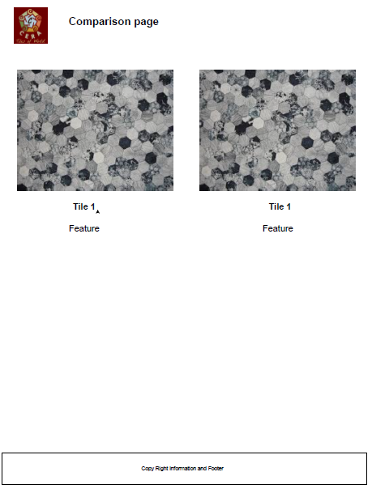

**Description:** This is the page of comparison of products when customers have selects 2 different products from sub-categories in order to compare features and information

## Task Sheet

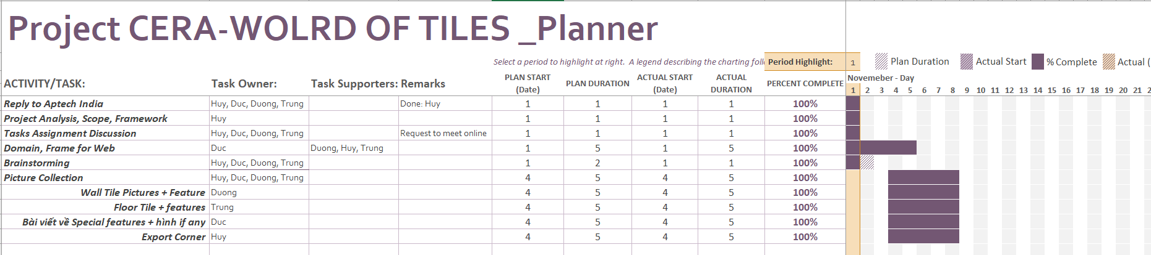

# REVIEW 2

# WEBSITE USER INTERFACE

### Homepage

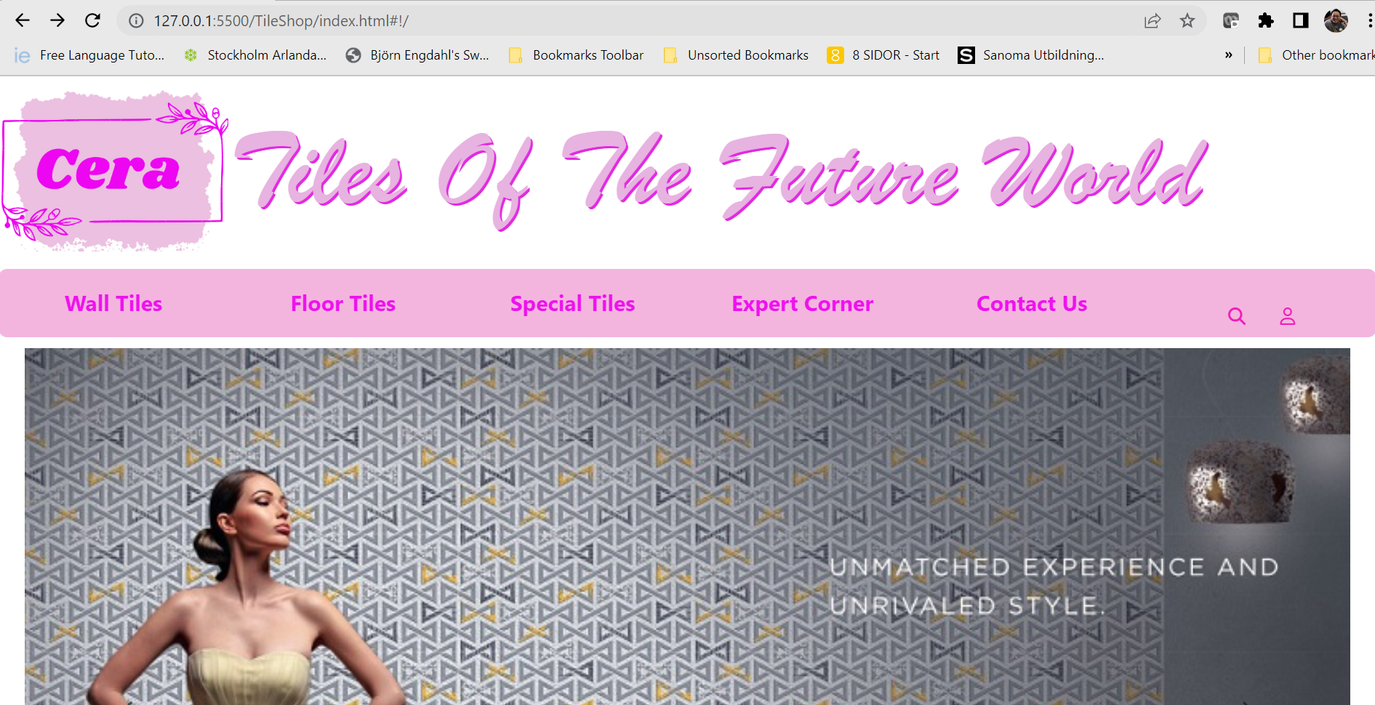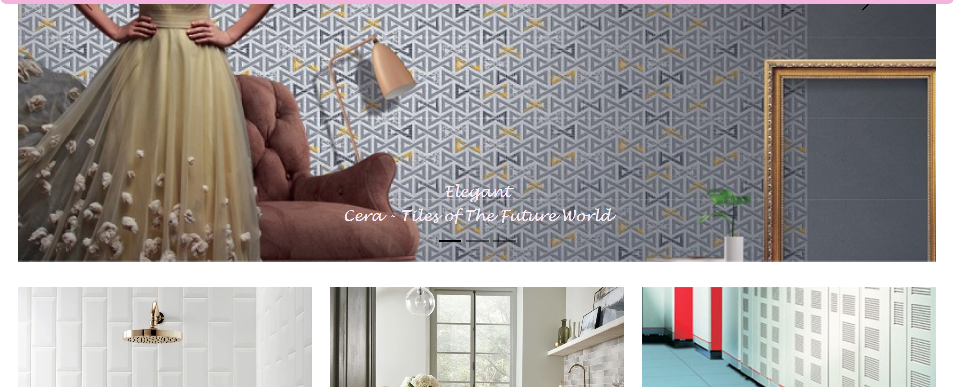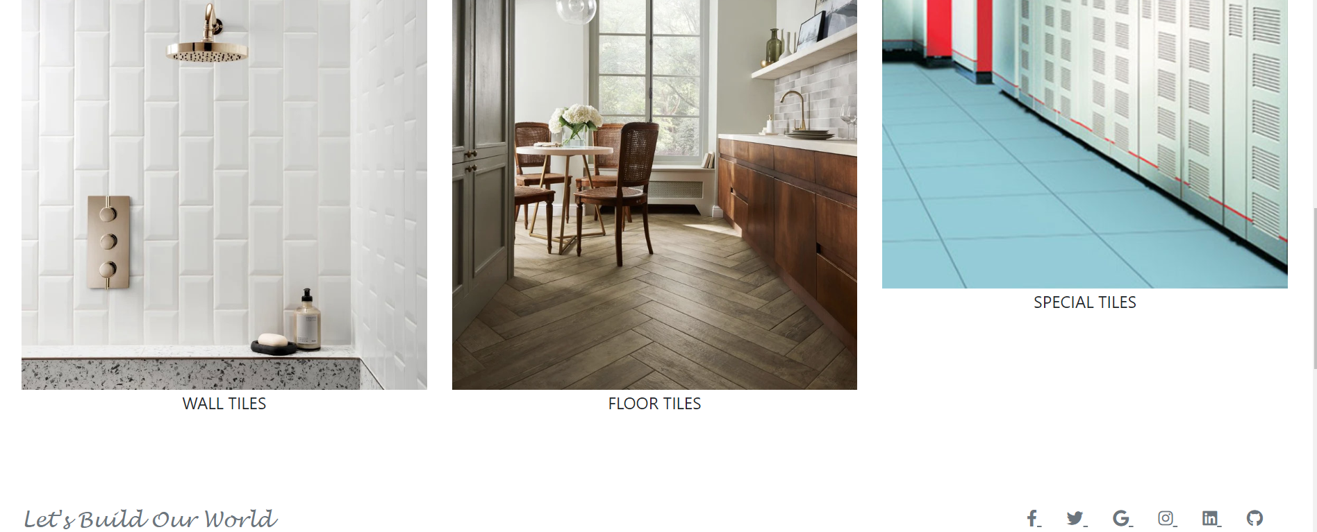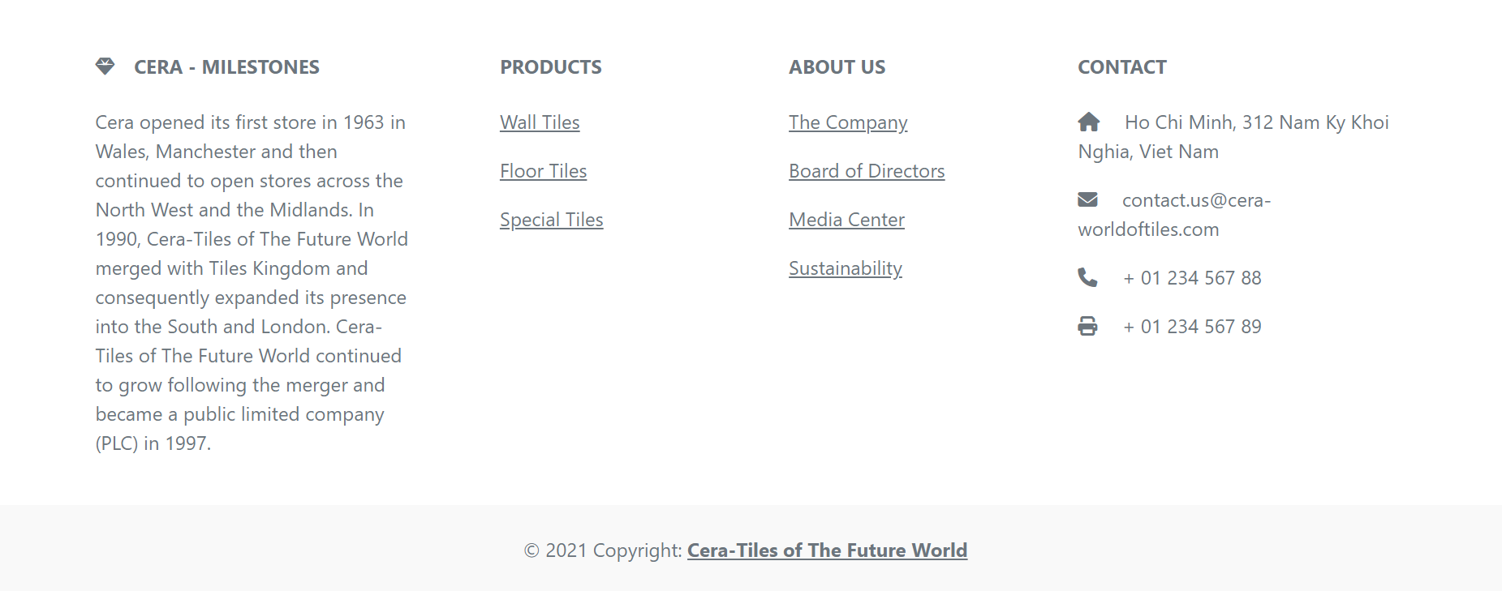

### Main Category

1. Wall Tiles

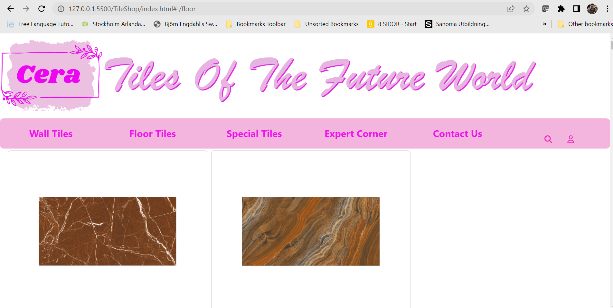

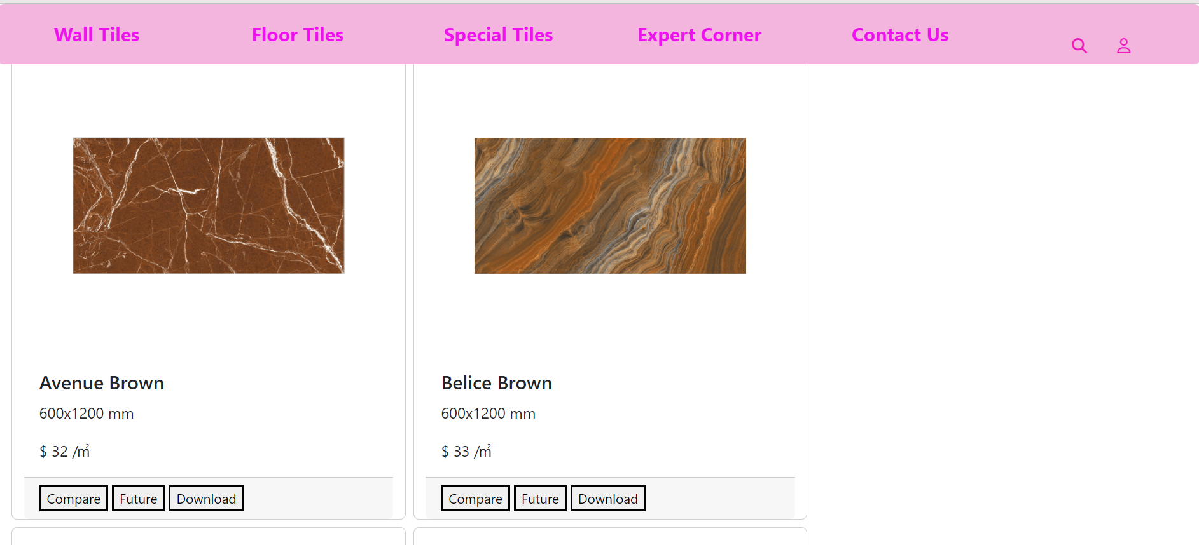

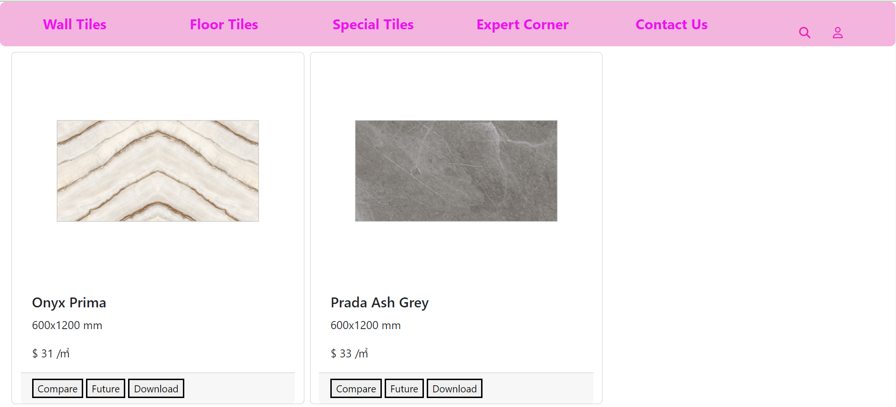

1. Floor Tile

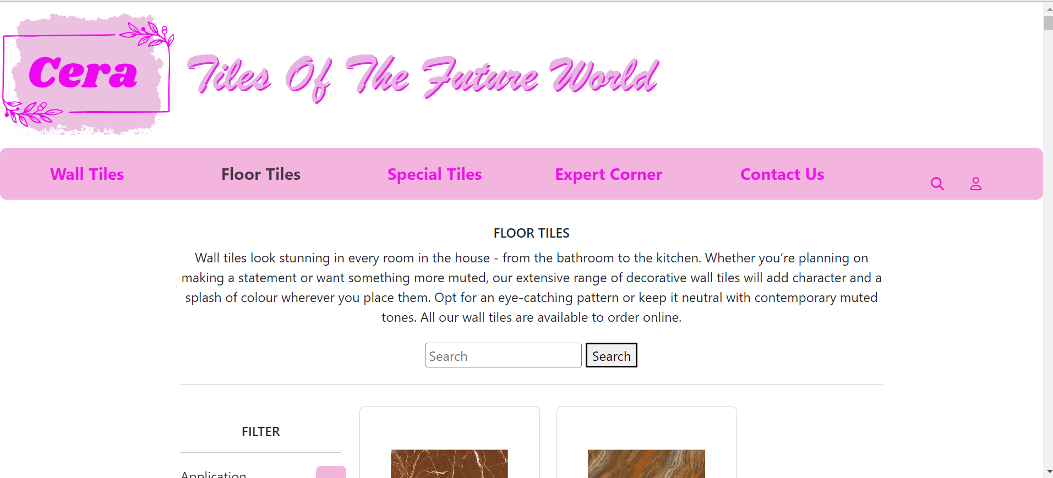

1. Special Tiles:

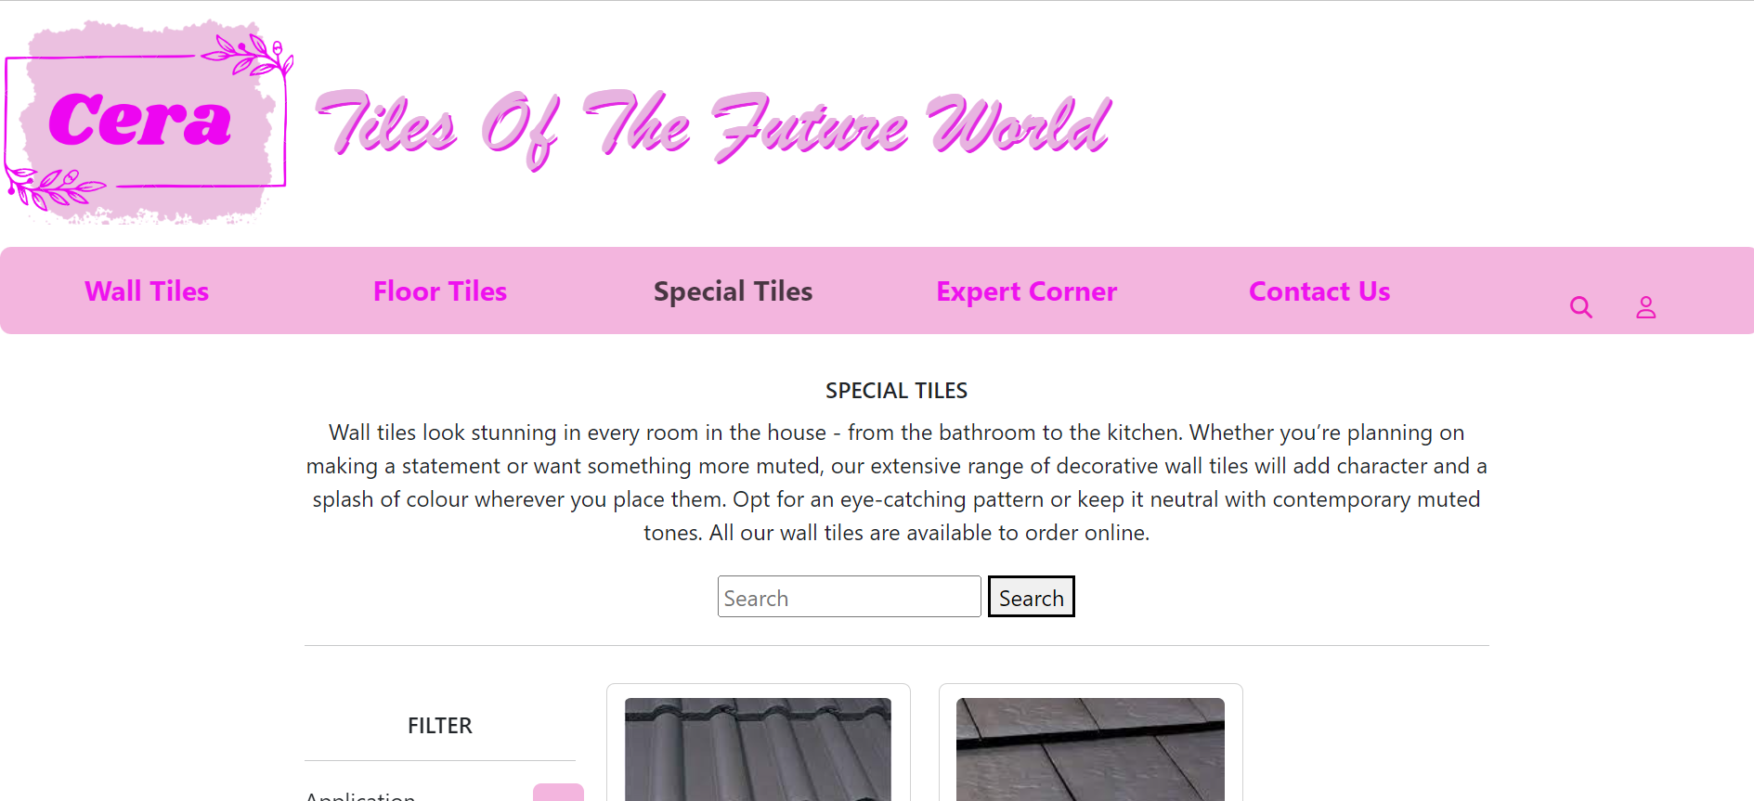

1. Expert Corner:

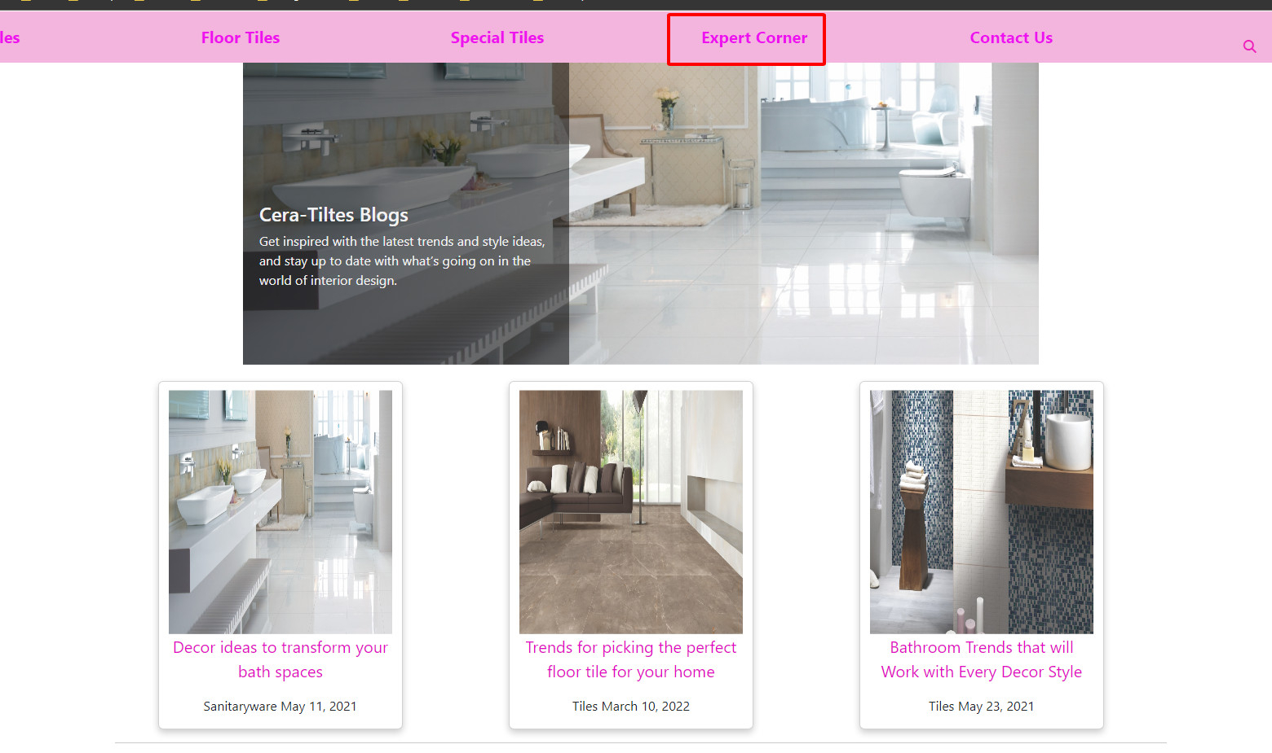

1. Filter/searching from home page:

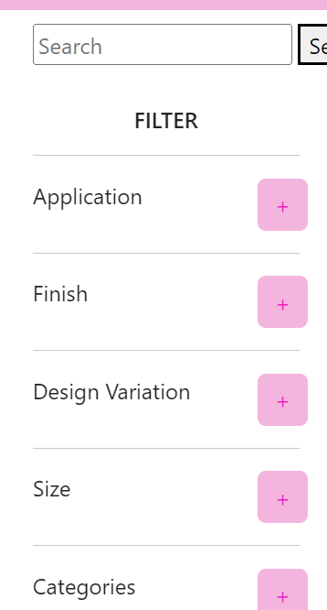

Users can enter to search products

1. Product: each of product can download document, compare and view feature

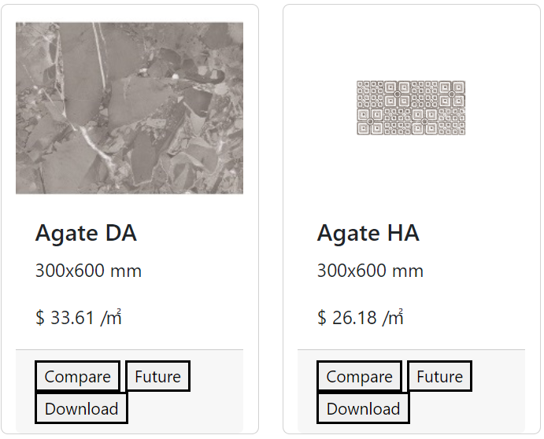

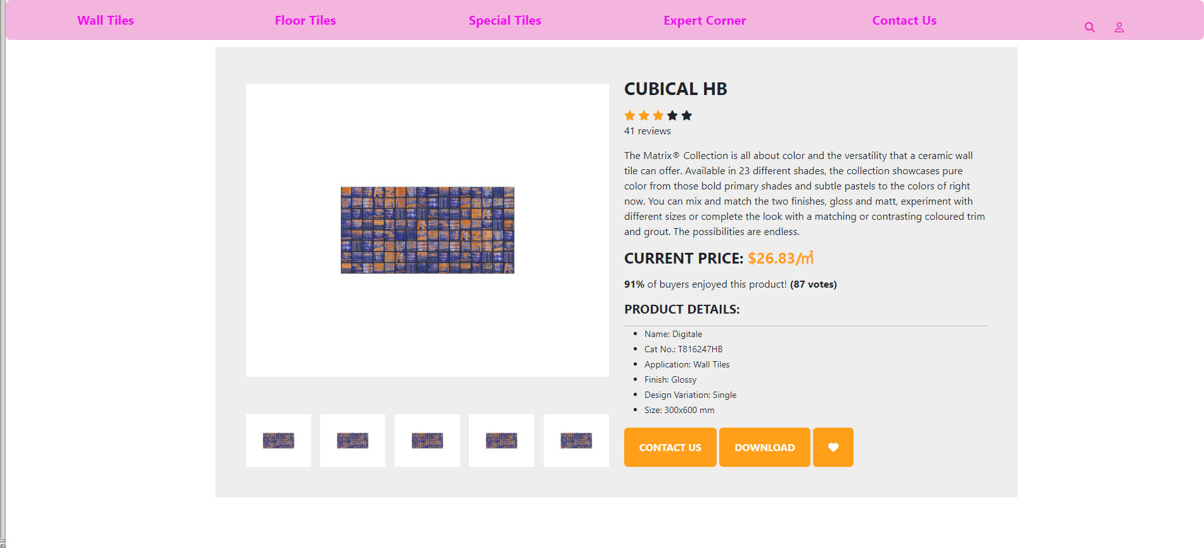

### Contact Page

